**Course 6: Design Thinking SA**

1. Student Name: Prakhar Sharma
2. Candidate Registration Number: 1000260
3. GITHUB LINK:
4. CRS Name: Artificial Intelligence
5. Course Name: IDAI
6. School Name: Ryan Global School, Kharghar

**Design a Smart System for Lost Individuals Support and Resource Mapping App prototype using a Design Thinking Approach.**

**Problem Statement:**

Vulnerable groups, including children, the elderly, and individuals with cognitive impairments, often face significant challenges when navigating unfamiliar environments, leading to increased anxiety and the risk of becoming lost. Current navigation and emergency assistance systems lack real-time updates, intuitive interfaces, and effective communication channels with caregivers or rescuers. As a result, these individuals may struggle to find safe locations or access necessary resources in critical situations.

**How might we design an intuitive mobile application that provides real-time navigation, connects lost individuals to nearby resources, and facilitates seamless communication with caregivers, ensuring their safety and well-being in unfamiliar surroundings?**

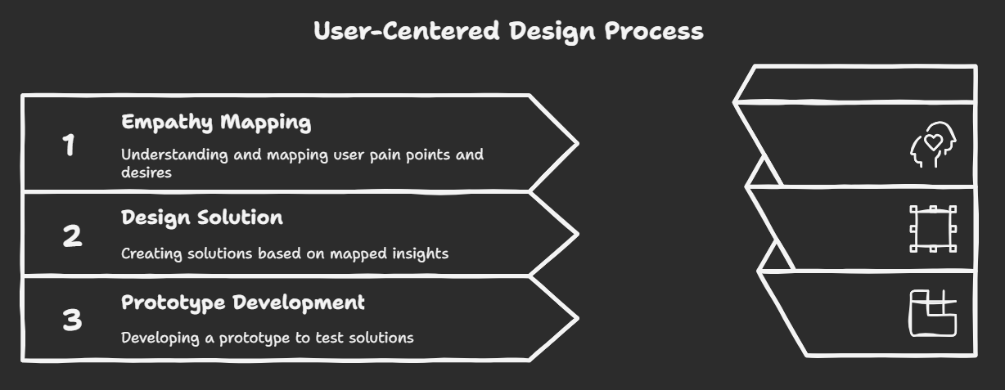

**Design Thinking Approach**

**Empathize: Researching Users' Needs**

**Step 1: Empathize and Define**

**User Research**

1*. Interviews and Observations* :

- Participants : 10 users from different demographics (children, elderly, individuals with cognitive impairments, and their caregivers).

- Questions :

- What challenges do you face when navigating unfamiliar areas?

- How do you currently seek help if you feel lost?

- What features would you find most helpful in an app designed for navigation and emergency support?

- Observations : Simulate scenarios where users might get lost and observe their reactions and decision-making processes.

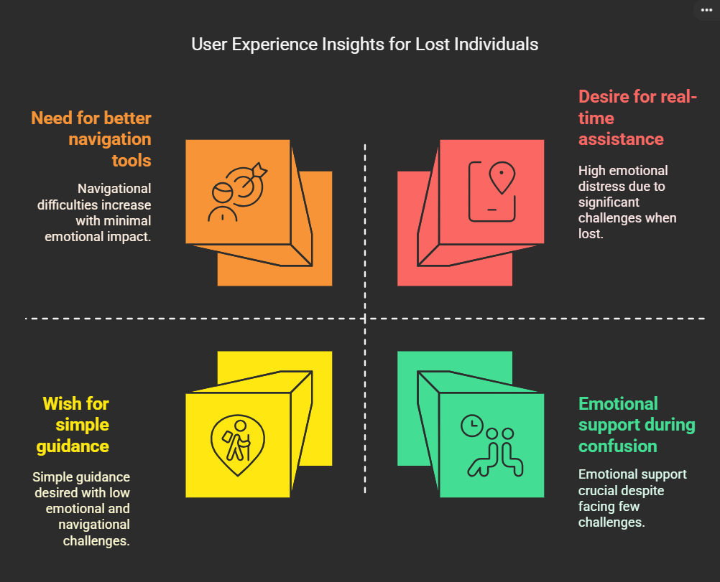

2. *Insights* :

- Elderly Users : Prefer simple interfaces with large buttons and clear instructions.

- Children : Need gamified elements to engage them and keep them focused.

- Cognitive Impairments : Visual cues and minimal text are required to avoid confusion.

**Empathy Mapping**

- Pain Points :

- Fear of being lost.

- Difficulty understanding complex maps.

- Need for immediate assistance and clear guidance.

- Desires :

- Simple, straightforward navigation.

- Instant connection to caregivers or emergency services.

**Empathy Mapping Insights**

Pain Points

1. **Fear of Being Lost**: Individuals often experience anxiety and panic when they realize they are lost, which can hinder their ability to think clearly and seek help.
2. **Difficulty Understanding Complex Maps**: Traditional maps can be overwhelming and confusing, especially for those who may not be familiar with the area or who have cognitive challenges.
3. **Need for Immediate Assistance and Clear Guidance**: In moments of distress, users require quick access to help and straightforward directions to regain their bearings.

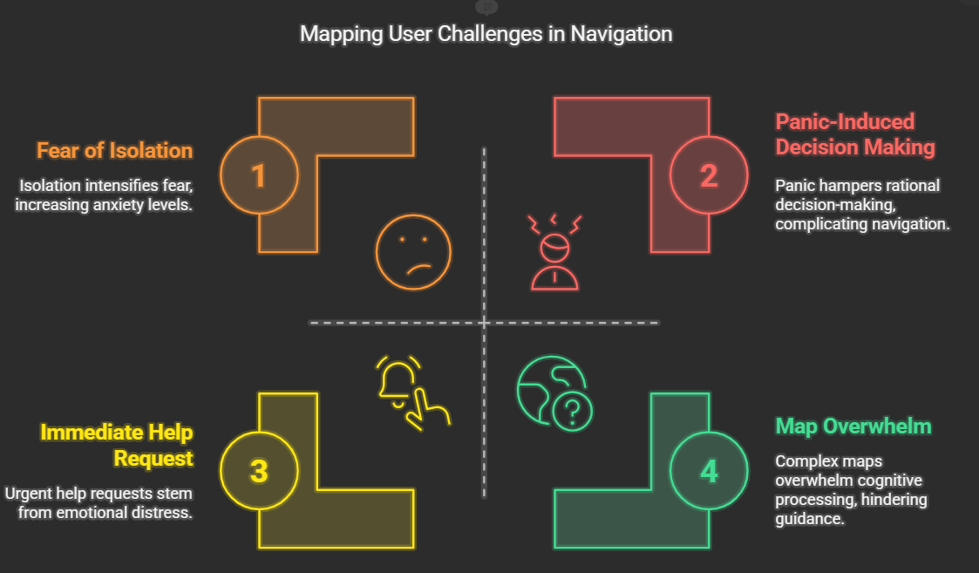

## Desires

1. **Simple, Straightforward Navigation**: Users want an intuitive interface that provides clear, easy-to-follow directions without unnecessary complexity.
2. **Instant Connection to Caregivers or Emergency Services**: There is a strong desire for a feature that allows users to quickly reach out for help, whether from friends, family, or emergency services.

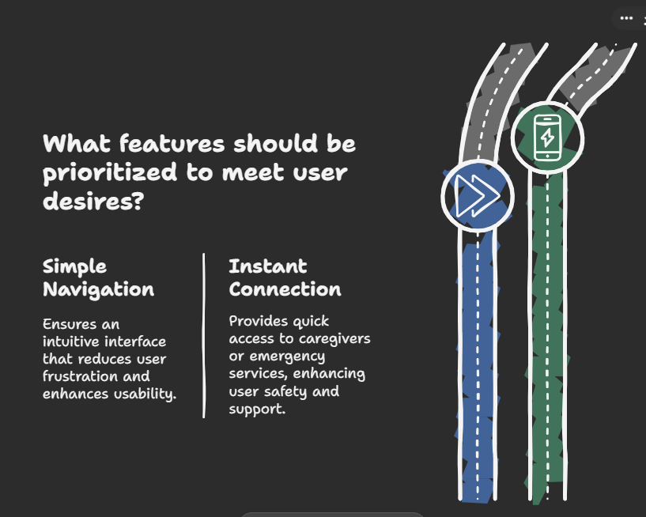

**SWOT Analysis**

| • **Customized Support**: Tailored features for children, the elderly, and individuals with cognitive impairments to enhance reliability in critical situations.  • **Real-Time Resource Mapping**: Instantly identifies local resources and support networks for quick assistance.  • **User-Friendly Interface**: Simple design for easy adoption, especially by technology-averse users.  • **Social Worker Partnerships**: Collaborating with experts to refine services and improve credibility.  • **Proactive Alert System**: Notifies caregivers when an individual goes missing, ensuring faster response times. | • **Limited Awareness**: Low initial adoption due to lack of understanding; requires targeted marketing.  • **Tech Literacy Barriers**: Non-tech-savvy users may struggle; strong onboarding support is essential.  •  **Resource Constraints**: Ongoing updates need funding; outdated information reduces reliability.  • **Privacy Concerns**: Handling sensitive data requires strong security to build user trust.  • **Integration Challenges**: Compatibility with existing support systems is key for seamless adoption. |
| --- | --- |
| https://524917b70575dd133464860a62657bfb.cdn.bubble.io/cdn-cgi/image/w=48,h=48,f=auto,dpr=1.5,fit=contain/f1721234679715x717057005299189100/thumbs-up_1f44d.pngStrengths | https://524917b70575dd133464860a62657bfb.cdn.bubble.io/cdn-cgi/image/w=48,h=48,f=auto,dpr=1.5,fit=contain/f1721234684546x201328315448712200/thumbs-down_1f44e.pngWeaknesses |
| • **Rising Safety Demand**: Increasing concerns for children and elderly safety create a growing market.  • **Awareness of Cognitive Impairments**: Educational efforts can position your system as a trusted solution.  • **Healthcare Partnerships**: Collaborations enhance credibility and expand audience reach.  • **Tech Advancements**: GPS and AI innovations improve functionality and market appeal.  • **Government Support**: Alignment with senior care initiatives opens funding and growth opportunities. | • **Strong Competition**: Established solutions make differentiation essential through unique features or pricing.  • **Fast Tech Changes**: Continuous innovation is needed to prevent obsolescence.  • **Digital Safety Concerns**: Transparency and strong security measures build user trust.  • **Economic Challenges**: Flexible pricing can help attract budget-conscious consumers.  • **Regulatory Compliance**: Adapting to evolving data protection laws is crucial to avoid legal issues. |
| https://524917b70575dd133464860a62657bfb.cdn.bubble.io/cdn-cgi/image/w=48,h=48,f=auto,dpr=1.5,fit=contain/f1721296594564x497637158885848800/raising-hands_1f64c.pngOpportunities | https://524917b70575dd133464860a62657bfb.cdn.bubble.io/cdn-cgi/image/w=48,h=48,f=auto,dpr=1.5,fit=contain/f1721296600341x107569279435477230/oncoming-fist_1f44a.pngThreats |

**User Persona Development**

- Persona Example :

- Name: Smita

- Age: 75

- Behavior : Struggles with traditional GPS navigation.

- Pain Point : Needs a simple interface with clear, step-by-step guidance.

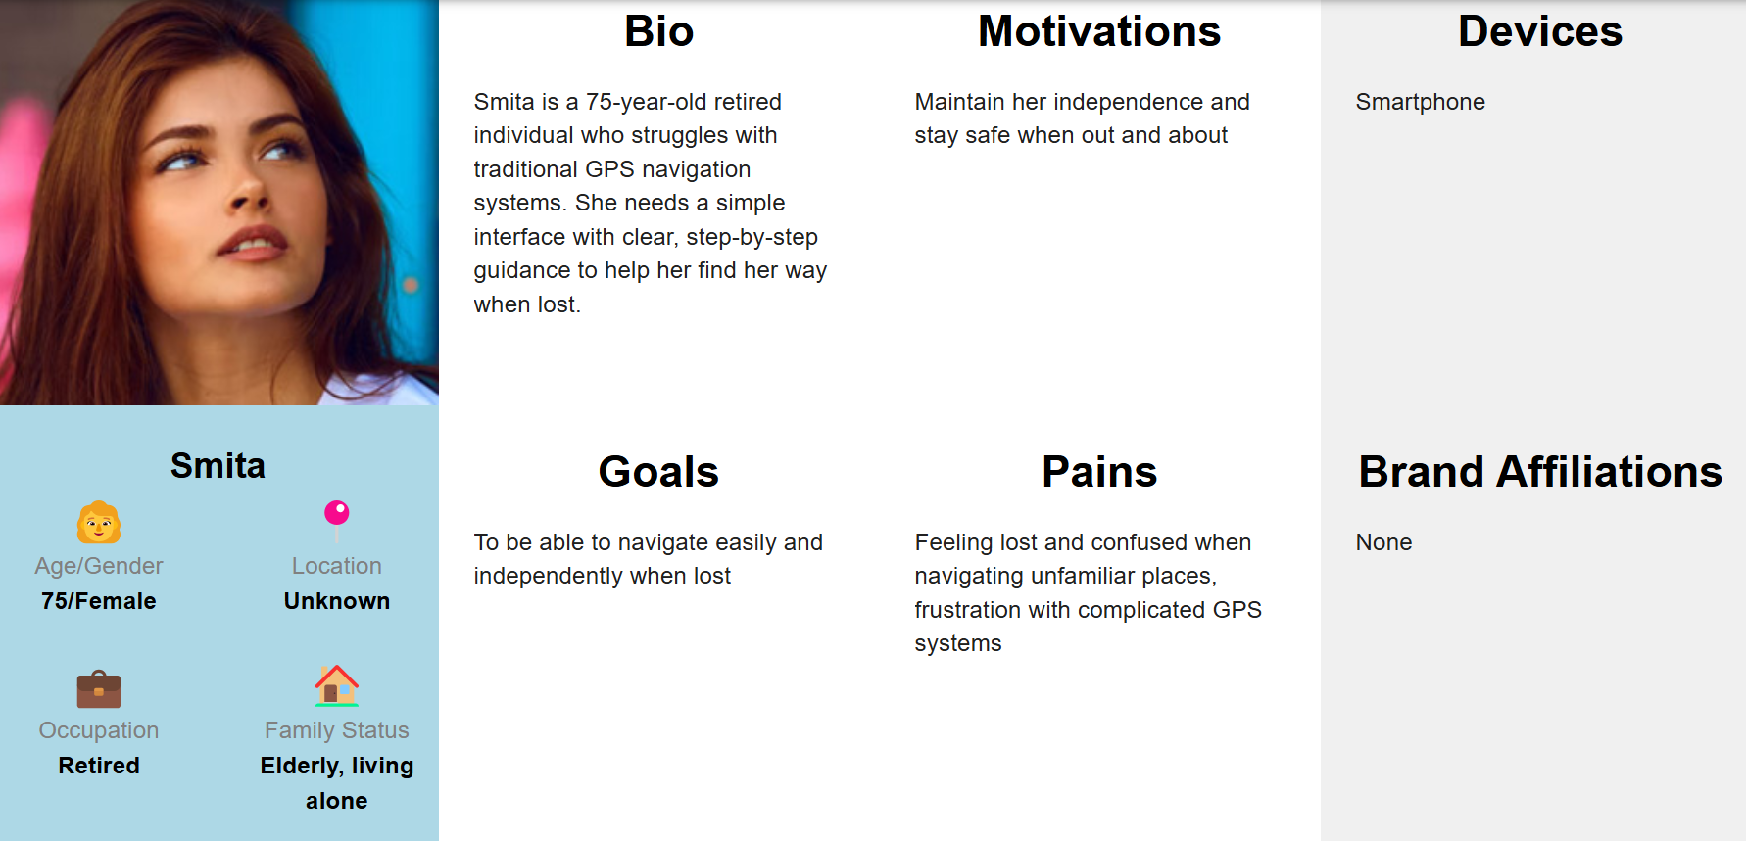

*Define*

Based on the empathy mapping insights, define the core problems that the app aims to solve:

* Users need a way to feel safe and secure when lost.
* Users require a user-friendly navigation system that simplifies map reading.
* Users need immediate access to support services.

**Problem Statemen**t

- How might we design an intuitive app that helps lost individuals safely navigate unfamiliar areas, connects them to resources, and provides real-time updates to caregivers?

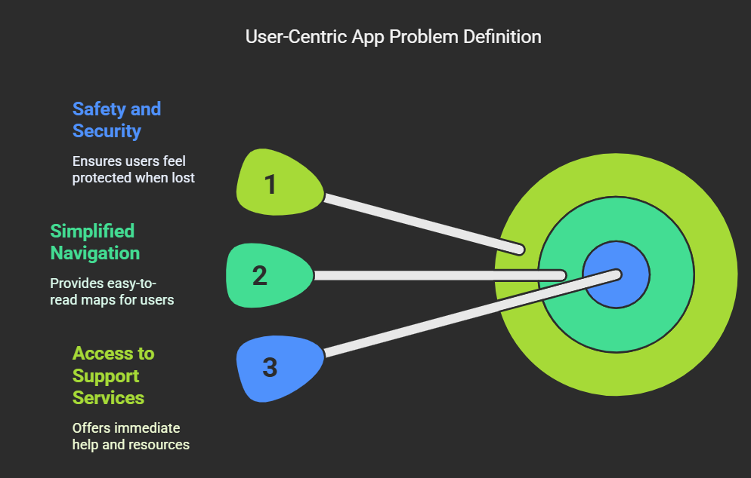

**Step 2: Ideate-** Brainstorm potential features and functionalities that could address the defined problems:

**Collaborative Brainstorming**

- *Innovative Features* :

- Visual SOS Flare : Sends location and emergency message.

- Emergency Resources Widget : Displays nearby resources.

- Multilingual and Accessible Interface : Supports various languages and audio guidance.

*Unique Concepts*

- Real-Time Mapping and Navigation : User-friendly maps with voice guidance.

- Caregiver Alerts : Periodic updates on the user’s location.

- Vibration Feedback for Alerts : Ensures alerts are noticed in noisy environments.

* User-Friendly Interface: A minimalistic design that highlights essential navigation features.
* Voice Navigation: Implement voice-guided directions to reduce the need for users to read complex maps.
* SOS Button: A prominent button that connects users to emergency services or designated contacts with a single tap.
* Location Sharing: Allow users to share their location with trusted contacts for added security.

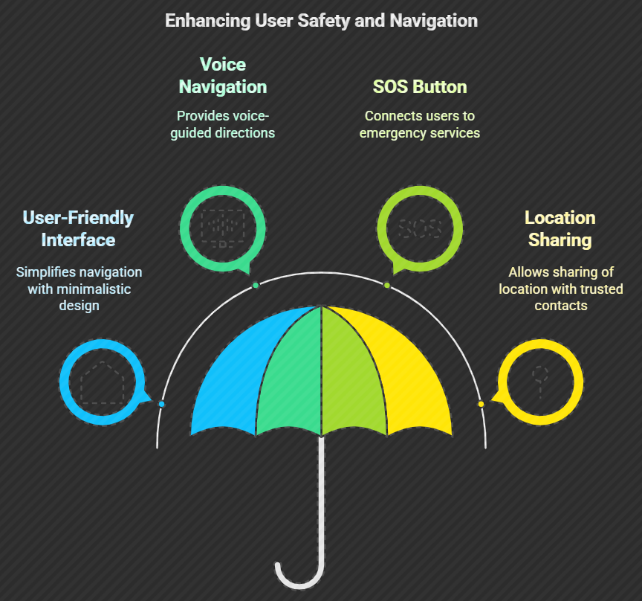

**Step 3: Prototype-** Create a low-fidelity prototype of the app that includes the following key screens:

**Prototype Requirements and Features**

1. Home Screen: Displays the user’s current location and a simple navigation bar.

Login/Sign-Up and Home Page:-

- Simple login/sign-up with minimal input.

The home page shows a map with emergency resources and a prominent SOS button.

2. Real-Time Navigation : Provides step-by-step voice-guided directions with visual cues :

- Voice-enabled, step-by-step directions with visual prompts.

3. Caregiver Alerts :

- Sends updates to family members about the user’s location.

4. Resource Mapping :

- Displays resources within a 500-meter radius with color-coded icons.

5. SOS Alert System :

- Emergency flare that shares location and message with caregivers.

6. Multilingual Support :

- Language preferences for diverse users.

7. Vibration Feedback for Alerts :

- Vibration notifications for alerts.

Tools Suggested

**Step 4: Test**

**User Testing**

1*. Prototype Testing* :

- Conduct usability tests with a group of users from the target demographics.

- Gather feedback on the app’s usability, clarity, and effectiveness in emergencies.

2. *Feedback Collection* :

- Use surveys and interviews to collect qualitative data on user experience.

- Identify areas for improvement based on user interactions.

3*. Iterate* :

- Refine the prototype based on user feedback.

- Focus on enhancing features that users found confusing or difficult to use.

**Step 5: Implement**

**Final Development**

- Collaborate with developers to build the app based on the refined prototype.

- Ensure that the app is tested in real-world scenarios before launch.

**Launch and Monitor**

- Launch the app and monitor user engagement and feedback.

- Continuously update the app based on user needs and technological advancements.

* **Technologies & Tools used**

Napkin.ai

Uizard.ai

Motif.ai

Blackbox.ai

OnlinePersona creator- uxpressia.com/personas-online-tool, user persona.dev/

https://founderpal.ai/swot-analysis-generator

CHAT GPT

* **Demo & Screenshots**

**Conclusion**

The Smart System for Lost Individuals Support and Resource Mapping App prototype aims to alleviate the fears and challenges faced by individuals when they find themselves lost. By employing a design thinking approach, the app is tailored to meet user needs, providing simple navigation and immediate access to assistance. Through continuous testing and iteration, the app can evolve into a reliable resource for those in distress, ultimately enhancing their sense of safety and security.

By following the Design Thinking approach, you can create a Smart System for Lost Individuals Support and a Resource Mapping App that effectively addresses the needs of vulnerable groups. The iterative process of empathizing, defining, ideating, prototyping, and testing will ensure that the final product is user-friendly, effective, and impactful.

**Persona**

**Persona 1:** Sumit**, the Elderly User**

* **Name**: Sumit Patel
* **Age**: 70
* **Occupation**: Retired Teacher
* **Location**: Suburban area
* **Technology Proficiency**: Basic (uses a smartphone for calls and messaging)

**Background:**

Sarah lives alone and enjoys going for walks in her neighborhood and nearby parks. She has a close-knit family who often checks in on her, but she sometimes feels anxious when venturing into unfamiliar areas.

**Goals:**

* To feel safe and confident when exploring new places.
* To easily find her way back home if she gets lost.
* To communicate her location to her family in case of emergencies.

**Pain Points:**

* Struggles with complex navigation apps that have cluttered interfaces.
* Finds it difficult to read small text and understand complicated maps.
* Worries about not being able to get help quickly if she feels lost.

**Motivations:**

* Values independence and wants to maintain an active lifestyle.
* Desires peace of mind for herself and her family regarding her safety.

**Context of Use:**

* Uses the app primarily when going for walks or visiting new places.
* Needs the app to be intuitive and easy to navigate, especially in stressful situations.

**Quotes:**

"I just want an app that tells me where to go without all the fuss. Clear directions and a big button for help would be perfect."

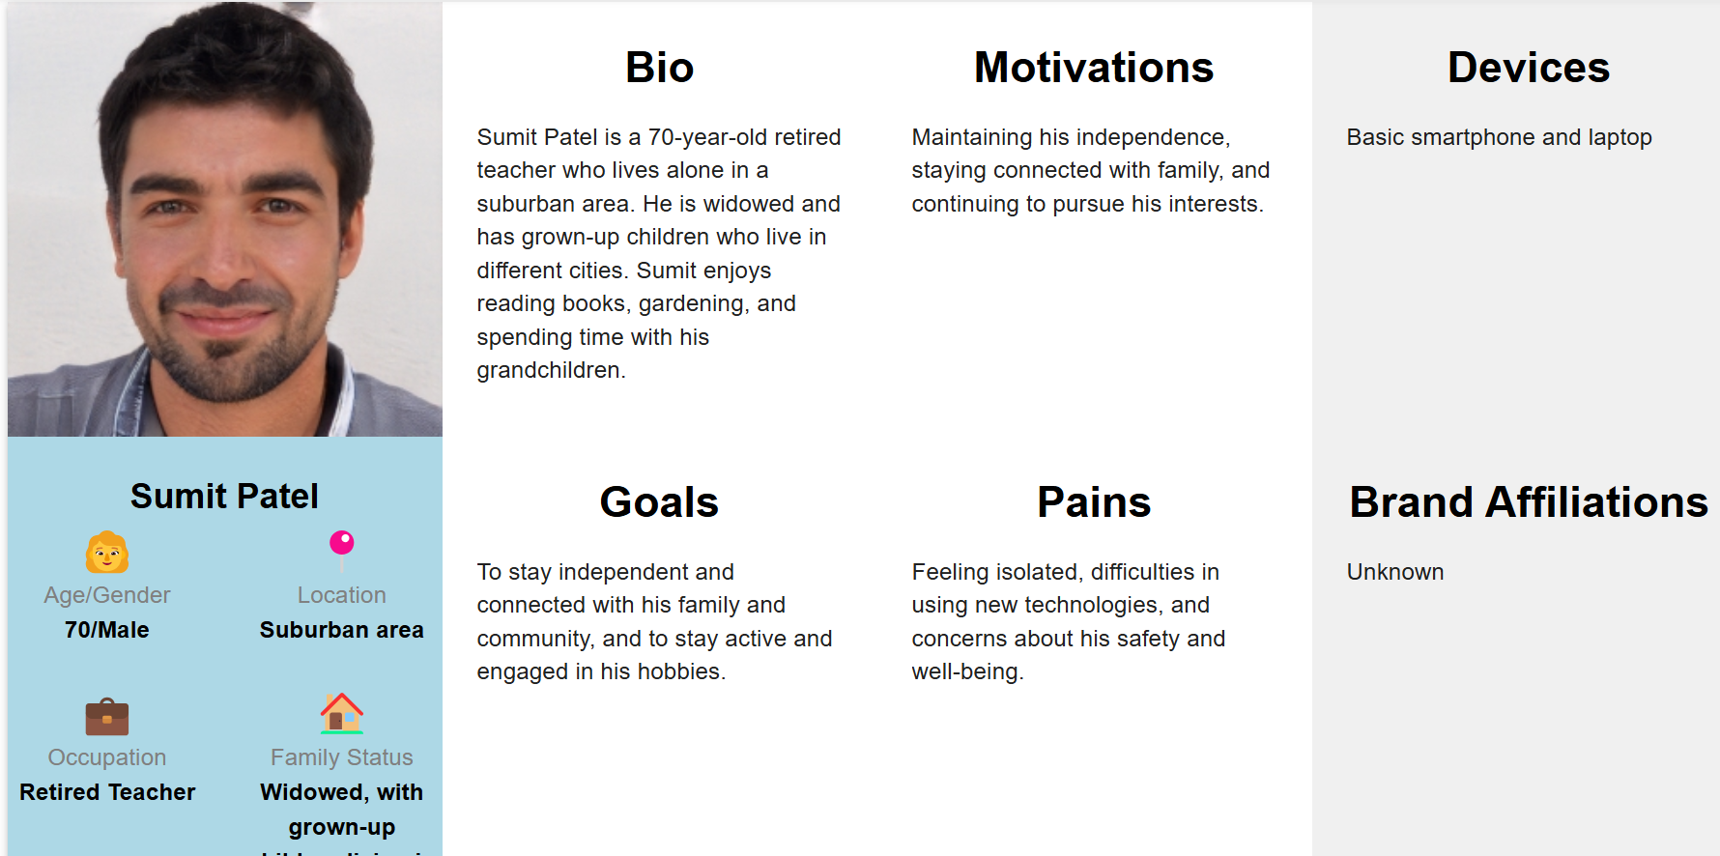

**Persona 2: Ram, the Caregiver**

* **Name**: Ram Krishnan
* **Age**: 35
* **Occupation**: Social Worker
* **Location**: Urban area
* **Technology Proficiency**: Advanced (frequently uses apps for work and personal use)

**Background:**

Jake works with elderly clients and individuals with cognitive impairments. He often accompanies them on outings and is responsible for their safety. He is always looking for tools that can help him monitor their well-being and provide immediate assistance if needed.

**Goals:**

* To ensure the safety of his clients while they are out in the community.
* To receive real-time updates on their location and status.
* To have a quick way to communicate with them in case of emergencies.

**Pain Points:**

* Current systems for tracking clients are often outdated and lack real-time capabilities.
* He feels anxious when clients are out of sight, especially in crowded areas.
* Needs a reliable way to alert emergency services if a client is in distress.

**Motivations:**

* Passionate about helping vulnerable populations and ensuring their safety.
* Seeks to improve the quality of care and support he provides to his clients.

**Context of Use:**

* Uses the app during outings with clients and while monitoring their activities.
* Needs the app to provide quick access to emergency resources and communication tools.

**Quotes:**

"I need to know where my clients are at all times. An app that keeps me updated would give me peace of mind."

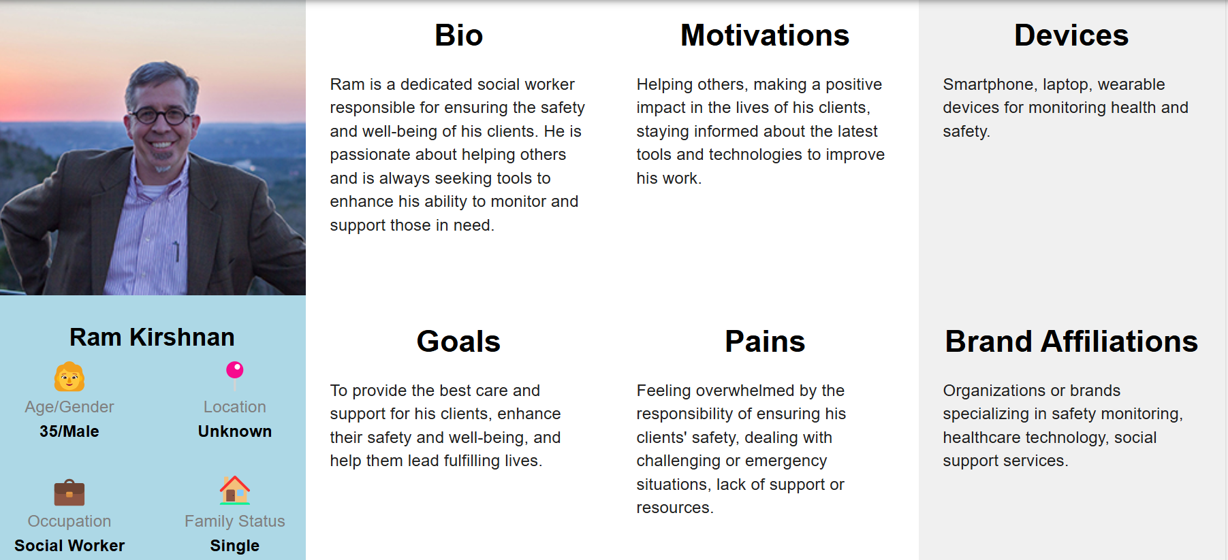

**Persona 3: Mia, the Child**

* **Name**: Mia Johnson
* **Age**: 10
* **Occupation**: Student
* **Location**: Urban area
* **Technology Proficiency**: Intermediate (uses a tablet and smartphone for games and educational apps)

**Background:**

Mia is an adventurous child who loves exploring parks and playgrounds. However, she sometimes gets lost when playing with friends in unfamiliar areas. She enjoys using technology and is familiar with apps designed for kids.

**Goals:**

* To find her way back to her parents or a safe place if she gets lost.
* To have fun while using an app that helps her navigate.
* To feel empowered and confident when exploring new environments.

**Pain Points:**

* Gets overwhelmed by complicated maps and instructions.
* Needs an app that is engaging and easy to use.
* Worries about not being able to communicate with her parents if she feels lost.

**Motivations:**

* Loves adventure and wants to explore new places safely.
* Desires independence while still feeling secure.

**Context of Use:**

* Uses the app while playing outside or exploring new areas with friends.
* Needs the app to be visually appealing and gamified to keep her engaged.

**Quotes:**

"I want an app that can help me find my way back home and is fun to use, like a game!"

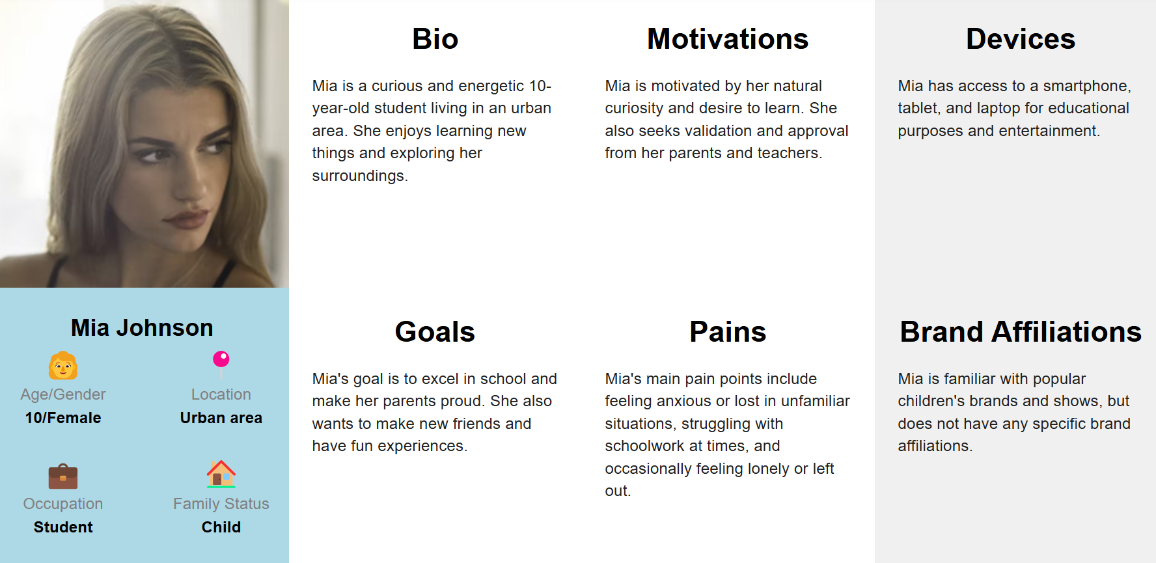

**Summary of Design Thinking Aspects Covered**

1. **Empathize**: Each persona reflects the unique experiences and emotions of different user groups, helping the design team understand their needs and challenges.
2. **Define**: The personas highlight specific goals and pain points, allowing the team to define the core problems that need to be addressed in the app.
3. **Ideate**: Understanding the motivations and contexts of use for each persona can inspire innovative features and solutions tailored to their needs.
4. **Prototype**: The personas guide the design of the app's interface and functionalities, ensuring that they are user-friendly and accessible for each target group.
5. **Test**: By considering the personas during testing, the team can evaluate how well the app meets the needs of each user group and make necessary adjustments based on feedback.

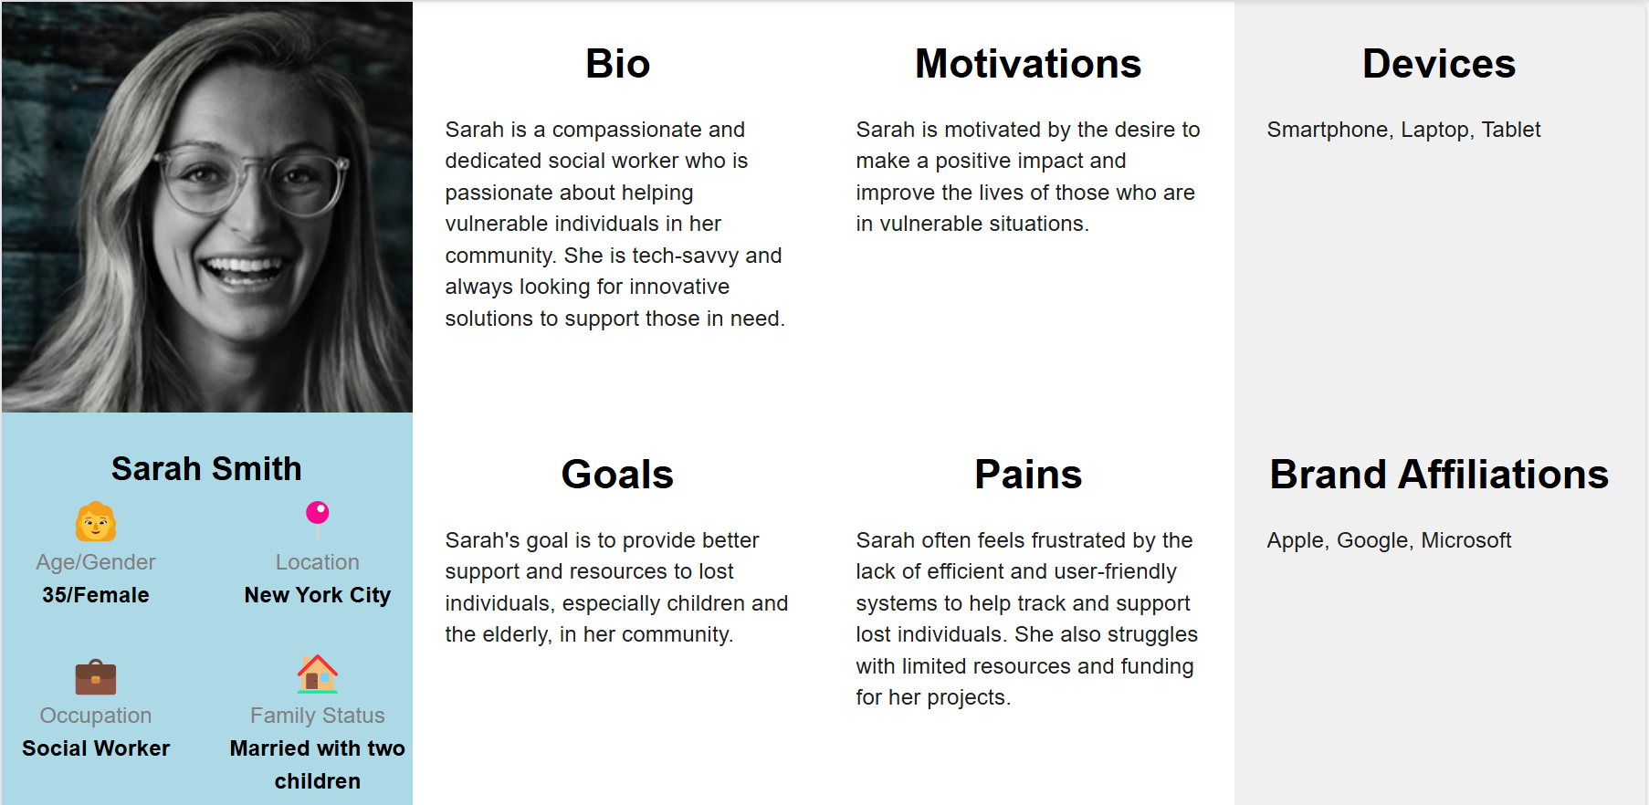

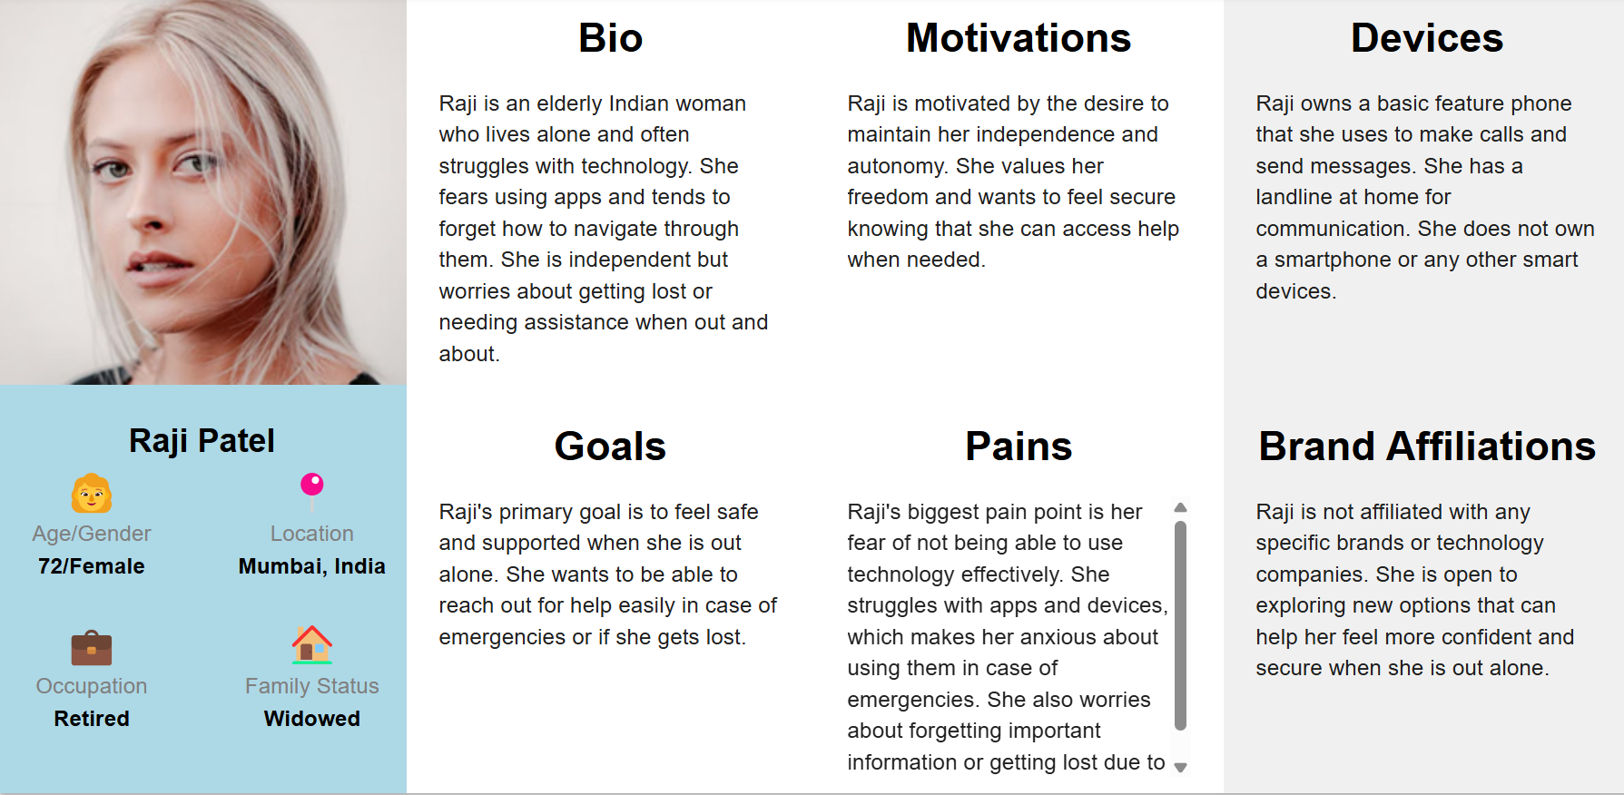

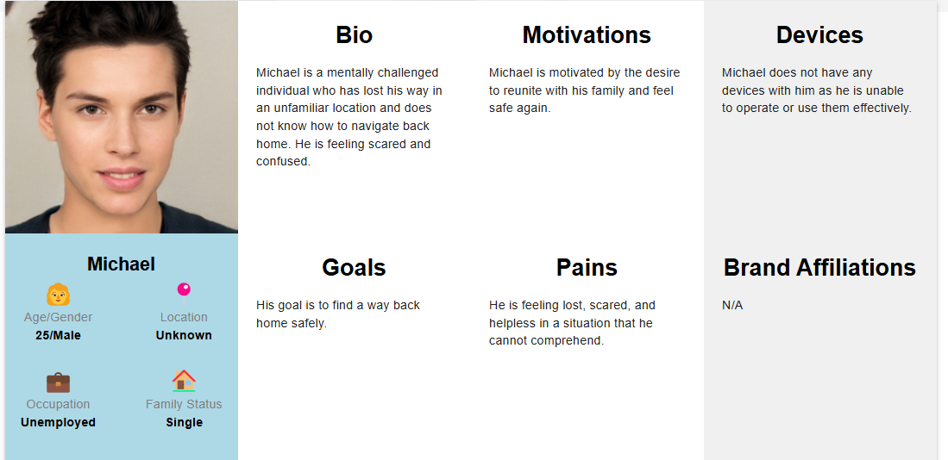

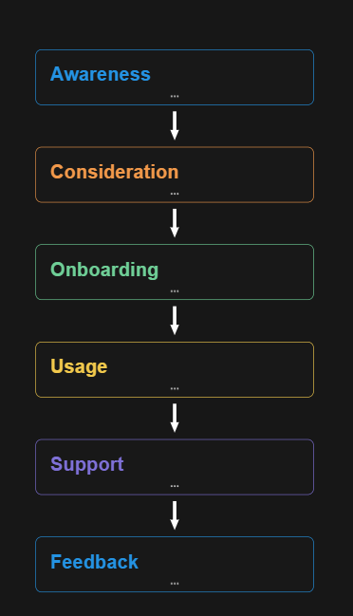

USER Interface

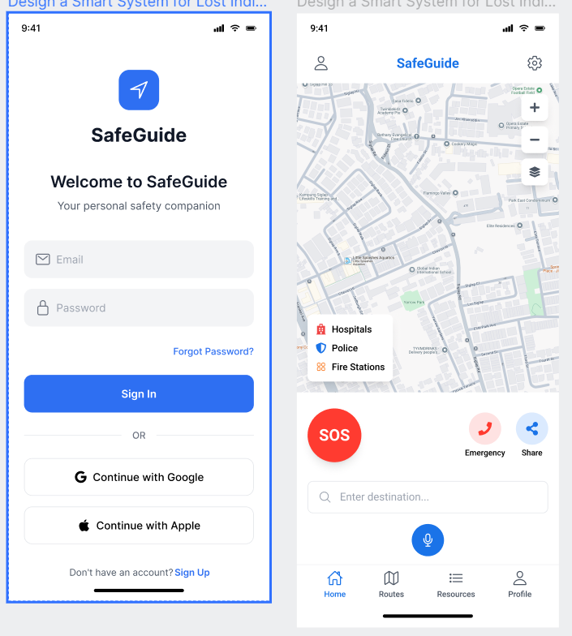

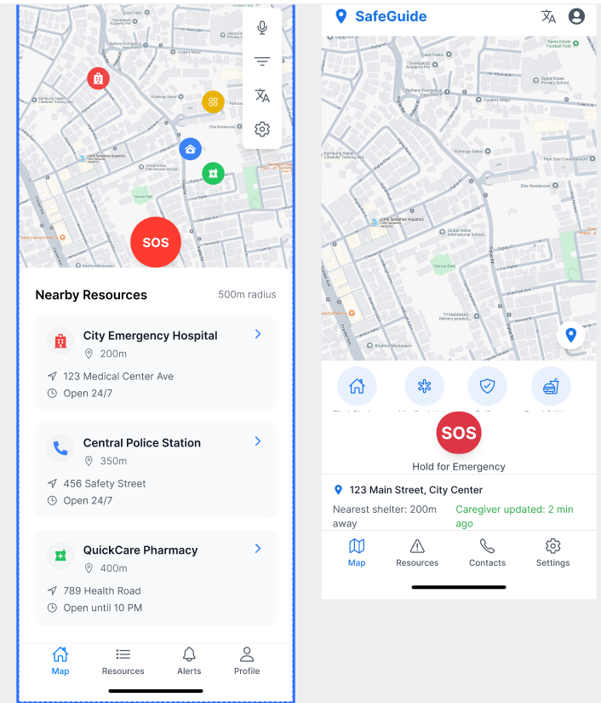

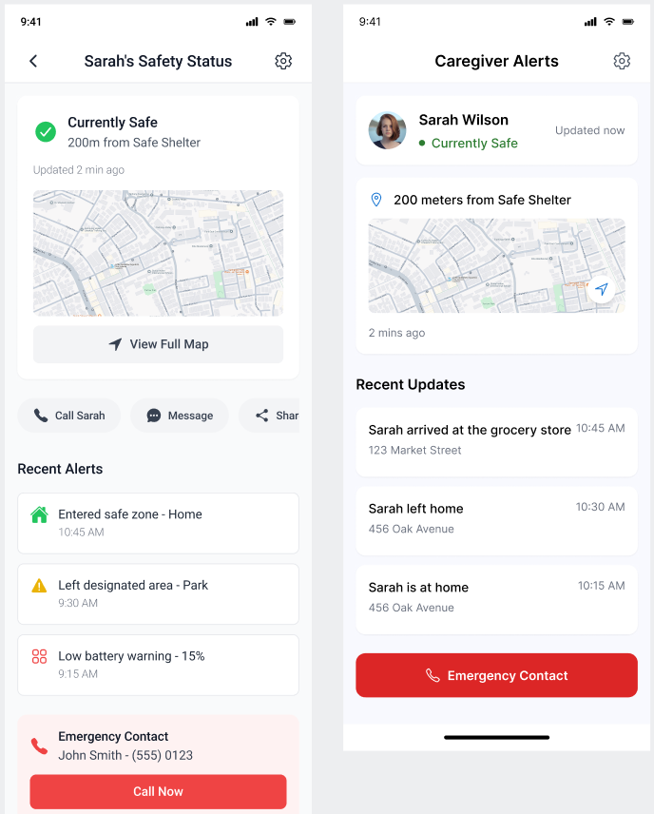

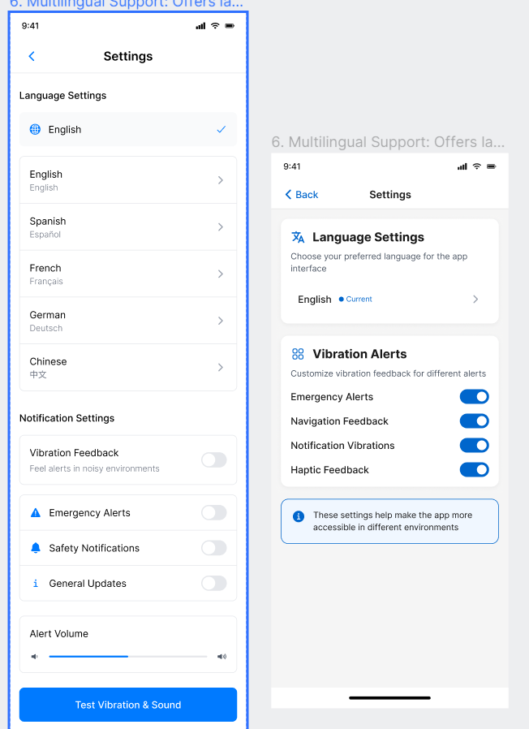

• **User_A**: Needed a police station and was guided to the nearest one.

• **User_B**: Needed medical help and was directed to a nearby hospital.

• **User_C**: Got lost in a market and received AI chatbot guidance.

Prototype for app

<https://ugrwmfgcmrpfprywnau75t.streamlit.app/>